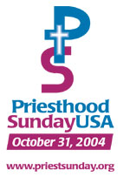  Crated especially for you by  …………………………………….  School of Religion | Priesthood Sunday  