Purpose: Ascension School Board |  |  | President: Bryan Back |  |  | Secretary:  Olivia Ludlum
 |  |  | Meeting Date: October 18, 2022
The Vision of the Ascension staff is to foster a Catholic community that models Jesus’ teaching at home, school and in our community. We strive to ensure an academic program of excellence, which challenges each student to achieve his/her maximum potential. Our goal is to expand student involvement in global issues, technology, foreign language, and cultural programs.
Living Faith |  | We achieve through sustained prayer and faith-filled interaction with each other that marks us as Ascension.
Embracing Community |  | We achieve through active participation in service to our parish, neighborhood, metro areas and global community.
Encouraging Opportunity |  | We achieve through activities, whether in traditional or community classrooms, to enhance ways in which students learn so they can continue to be life-long learners.
Respecting  Giftedness |  | We achieve by providing a level of instruction to challenge students to extend beyond the basics to maximize their potential in their areas of strength.
Celebrating  Excellence |  | We achieve through recognition of student accomplishments and alumni that say, “Well done!”
In Attendance: Terry Mullaney, Father Adam Carrico, Dr. Mary Beth Bowling, Bryan Back, Helen Walter, Mandy Goodwin, Natalie Ising, Juli Evers, Katie Spencer, John Amback, Laura Krebs Lewis, Olivia Ludlum.

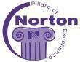  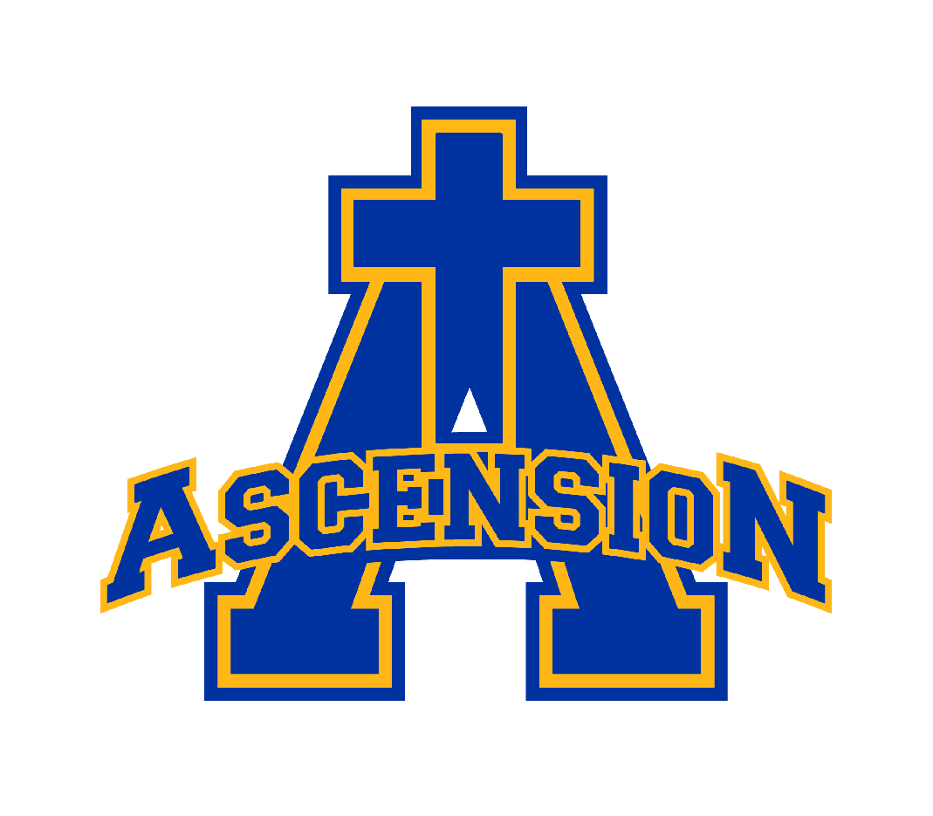 | Topic |  |  | Presenter | Discussion, Assignment and Responsibilities |  | Follow-  Up
 | Approval of Minutes |  |  |  | Email
Living Faith | Opening Prayer |  |  | Father Adam | Prayer led by Father Adam
 | Role of a school board in a parish school presentation  Questions/Closing  Open House |  |  | Dr. Mary Beth Bowling - Superintendent  Natalie Ising  Katie Spencer  Dr. Mary Beth Bowling  Bryan Back  Natalie Ising  Father Adam  Various Board Members  Bryan Back + Terry Mullaney  John Amback  Juli Evers | Goal: Provide support and direction to enable the Ascension School Board, the Pastor and Principal to function at a high level to successfully support the formation and education of students.  - Why do we participate on the school board? To serve Jesus Christ and the students sitting in desks. If other conflicts are getting in the way we should focus on resolution.  - Explained and reviewed the four domains of national standards and benchmarks - which help to make an excellent Catholic school:  - Mission + Catholic Identity  - Governance + Leadership  - Academic Excellence  - Operational Vitality  If any of the four domains are not in balance, this is an opportunity for improvement.  - Consultative/Advisory Boards  - A school board is a consultative/advisory board, which participates in the policy making process by formulating, adopting, and recommending policy to the person with authority to enact it. The Authority is not bound by the board's advice.  - These boards have no power to make independent decisions, establish policies, or control the financial business of the institution.  - The Pastor and principal ultimately determine what board recommendations will be accepted and how they will be enforced or enacted.  - The Pastor has final authority, per Canon law.  - Ideally, there are collaborative efforts, revisiting, continued dialogue, and compromise to reach a goal.  Roles and Responsibilities; A collaborative effort:  - Set Direction (policy)  - Formulating policy is the responsibility of the board.  - Pastor enacts policy  - Principal implements policy  - Ensure Results  - Board checks in on accountability measures.  - Board continues to provide oversight and feedback, exercises appropriate authority, provides accountability for the performance of the organization, and maintains the board bylaws.  Suggested areas of focus for the Board:  - Forming committees  - Reviewing/Revising bylaws (Every 3 years)  - Advisory board rubric - evaluate current and find ways to improve  - Parish Council liaison  - Finance LIaison  - Communication audit  Noted letters were sent to the Archdiocese and specific concerns raised, but not directly addressed previously and hoped those would be addressed in this forum. How will we address more specific issues, Sacramental Prep, what support are we being given to resolve? Are you here to work with us on resolving this conflict?  If a topic comes up, in which there is no consensus, with the child remaining in focus, but there is a large gap in ideology, how would we handle that?  Has Sacramental Prep been removed from the classroom? If not, some compromise has occurred. Canon Law says the Pastor has final say. Again, ideally there would be continued dialogue and communication to reach a compromise for a goal. Regarding specific concerns, she won’t tell the Pastor what to do. The support is in this room. She is not a mediator.  Bryan, as the school board president should be able to help lead to strategize a resolution.  Noted that he can help to lead the board in a more strategic way to come back as advisors and better leverage one another to solve and strategize on issues together.  Removing Sacramental Prep from the classroom continues to be a topic that is on the table. Would like a definitive answer. Also asked if Mentor had been assigned to Father Adam as outlined in the Archdiocese plan.  Sacramental Preparation is not being removed from the classroom. This was discussed in the Parish Council, noted Natalie attended. No mentor has been assigned, he has continued to inquire.  Were not aware of the Sacramental Preparation decision announced during Parish Council. Noted a need for better flow of information. Bryan Back to bring Parish Council notes as an item on School Board Agenda.  Open House signs  - Several still need to be placed  - Grab on your way out  Board to write thank you notes to open house attendees (11/1 meeting)  What additional resources does Ascension have - non educational?  (Guidance Counselor)  Map test scores being broken down into IXL areas,  Two Math Curriculums (Teacher led + Simple Solutions)  Parent question: Why don’t we use Chromebooks? topic for next meeting

Mission: As a vital ministry of the Church of the Ascension, our school’s mission is to recognize the uniqueness of all students in a caring, disciplined environment that exemplifies Christ’s command to serve one another. Ascension School fosters excellence in academics and promotes spiritual, intellectual, emotional, and physical growth of the whole child.
The faculty, supported by the parish staff, School Board, and Parent Teacher Organization (PTO), recognizes that students must be prepared to meet challenges of an ever changing world and to live cooperatively as critical thinkers and problem solvers in a global society. Love of GOD, human dignity, justice, ecumenism, service to others, stewardship, and excellence are among the values lived.

